

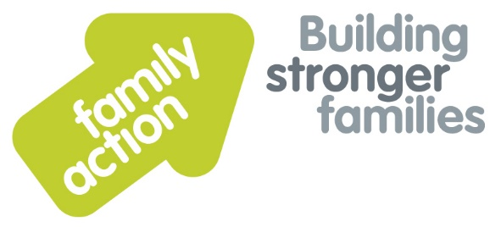

“When a flower doesn't bloom, you fix the environment in which it grows, not the flower.” Alexander Den Heijer

‘Plan Bee – Understanding and supporting your child or young person with additional needs’

‘Plan Bee’ is a FREE 3 week course (2hrs per week) written by two Clinical Psychologists working in Norfolk and is aimed at parents or carers of children or young people with additional needs including suspected or diagnosed ASD or ADHD.

During the three week course, we will explore:

* Behaviour as communication.

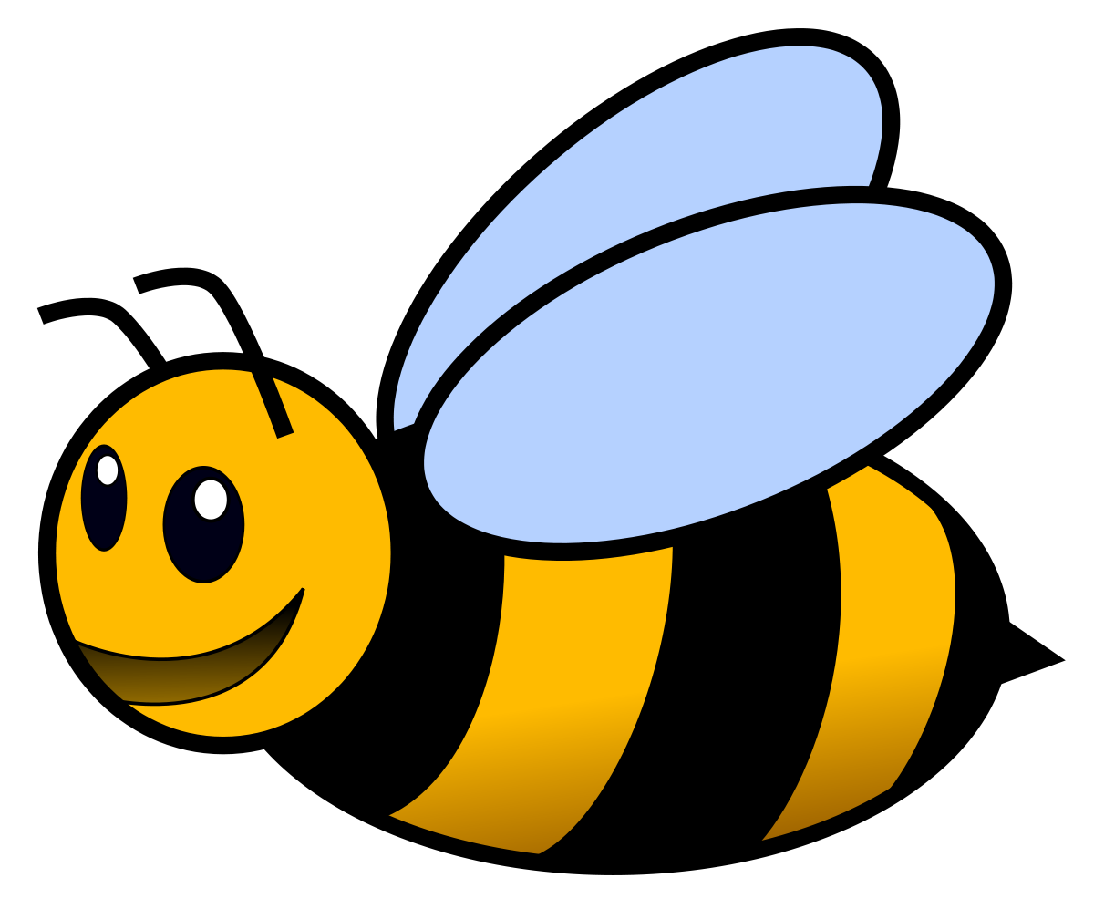

* Understanding the full range of needs your child may have.
* Developing a plan to support behaviour in difficult situations which can then be shared with grandparents, schools and others.
* Strategies for creating an environment in which your child or young person can thrive.
* Sharing experiences, challenges and successes with other parents experiencing similar issues and learning from these.

Courses Available to book:

**Great Yarmouth Primary Academy, Dickens Avenue, Great Yarmouth, NR30 3DT**

**18th, 25th Jan 2024 and 1st Feb 2024**

**09.30am until 11.30pm**

Places are limited.

**You must reserve your place** by contacting [gorleston@family-action.org.uk](mailto:gorleston@family-action.org.uk) or call us 01493 650220 for more information.